**Bachi –**

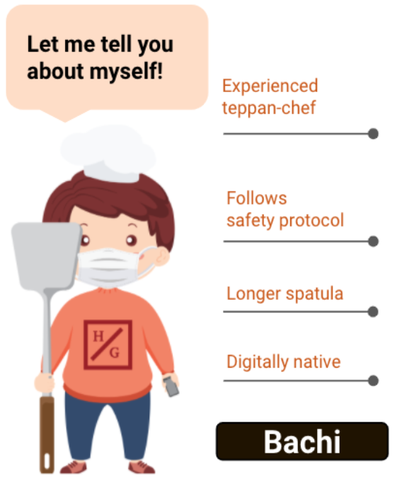We’ve created a mascot in order to better market our hibachi restaurant. People can easily recognize Bachi because of this long spatula.

Bachi symbolize the effort that we put into our restaurant to ensure the safety of our customers. He have a mask, mobile ordering, and a socially distance-able spatula